AI Final Assignment:
Scientific Abstracts Classification

LIU ZHUORONG
260020304855
31889: Artificial Intelligence
College of Information Science and Engineering

- Introduction
  - Overview of the Project

The main goal of this project is to use abstracts in a selected field to train a machine-learning model and test its categorizing scientific abstracts ability’s accuracy. Three fields were selected: Astronomy, psychology, and sociology. The main process includes data acquisition, preprocessing, model training, and validation. The following sections will explain the technologies used in each process, the experiment setting, and the comparison of the final results.

  - Key Concepts

Here are brief introductions about key concepts I focused on all processes.
    - Web Scraping

Web scraping involves using scripts or tools to access a website, analyze its content, and save the specific information in a structured format like a CSV file. It’s widely used for gathering data and collecting information from public sources.
    - BERT

BERT (Bidirectional Encoder Representations from Transformers) is a natural processing (NLP) model. It was developed by Google. Rather than process text sequentially, BERT uses bidirectional transformer architecture that can understand a context based on its left and right surroundings. Developers pre-trained the BERT model with massive text corpora and improved its capability. Currently, the BERT model can handle specific tasks with additional data.
    - K-Fold Cross-Validation

A methodology used to train and test the model by splitting the dataset into different folds instead of using a conventional train or test split.

K-fold: split the dataset into 10 equal parts (fold), training and testing the model 10 times. For each time, use a different fold as the testing set, and the rest as the training set.
    - Epoch

One complete pass through the entire training dataset. For example, if a dataset contains 900 samples, epoch 5 means the model will learn these 900 samples 5 times. A higher epoch may improve the accuracy of the model but also will cause overfitting.
    - Batch Size

The size of the subset (batch) that will be processed at the same time. For example, if we have 900 samples and a batch size of 30 means for each epoch, there will be 30 updates for the model, and the model will use the new subset as the processing data after each update.

- Methodology
  - Data Acquisition

Technology: Web scraping and arXIv web API.

Results: 900 paper titles and abstracts for three scientific fields: astronomy, psychology, and sociology. 300 titles and abstracts for each field. All the abstracts are saved in a CSV file called: research_abstracts.csv. The abstracts are labeled by their field name: astronomy, psychology, and sociology. Image 1 shows a part of the CSV dataset.

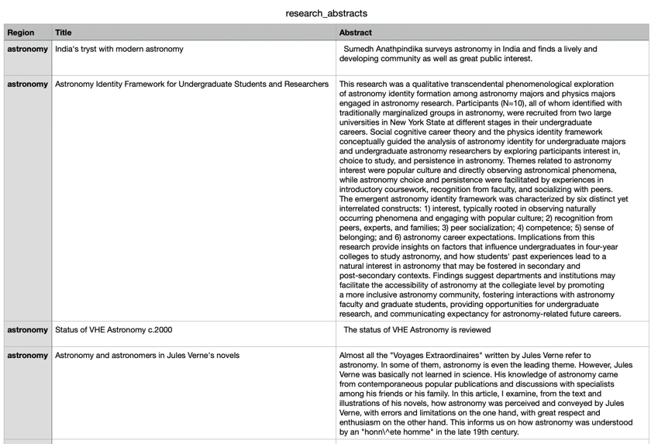

Image 1: A part of “research_abstracts.csv”

Code: Images 2-5 show the web scraping code that was used to conduct the dataset.

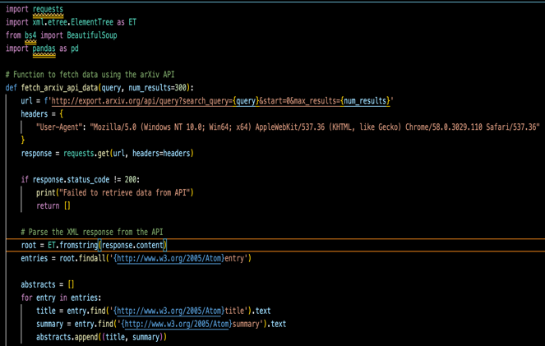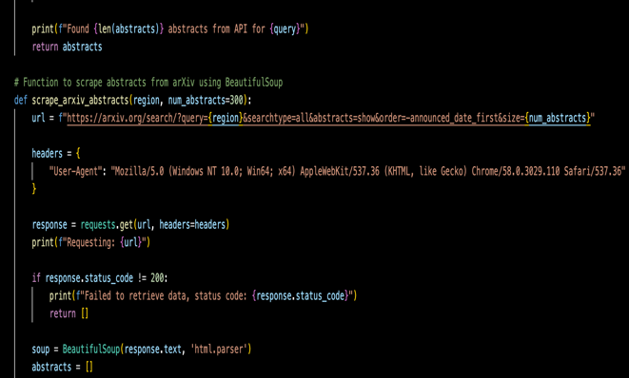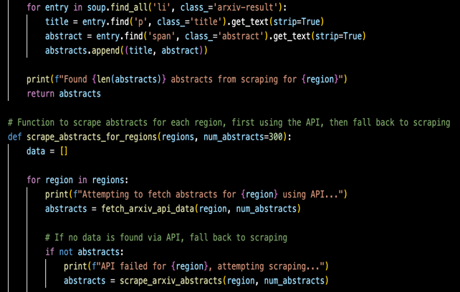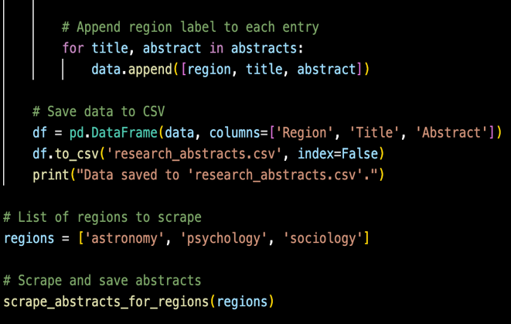

Images 2-5: Web scraping code “scrape2.py”

There were several problems when directly using web scraping and the website URL to gather specific information from the different website pages. When directly contacting a specific website with web scraping, several staff need to be checked: the permission for web scraping, the original code for the website, and the label of the div that contains the abstracts. Moreover, sometimes IP addresses will be banned by the website. This code combined API technology to make web scraping easier and more successful. API facilitates web scraping and makes it reliable because it directly accesses the data and avoids HTML content checking. API prevents overloading with the arXiv server by enforcing rate limitation, which maintains stable access rather than just using web scraping.

Combining Web scraping and the arXiv API makes the data acquisition process robust. API makes the scraping more structured and reliable, and web scraping can extract additional information.

  - Data preprocessing

Technology: PyCharm, BERT tokenization.

Code: Image 6 shows a screenshot of the code that conducts BERT tokenization.

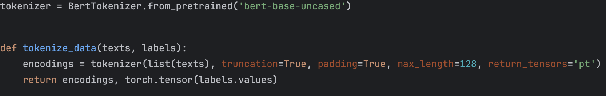

Image 6: BERT tokenization code in “model4.py”

Explanation: The BERT tokenizer will split the input text into subword units (tokens). For example, the word “singing” will be divided into “sing” and “ing.” Another example is if it is a sentence: “I love you,” it will be split into [“I”, “love”, “you”]. Image 6 shows a brief visualization of this technology. Then it will use padding, truncation, and max_length settings and maintain the size of each sentence the same.

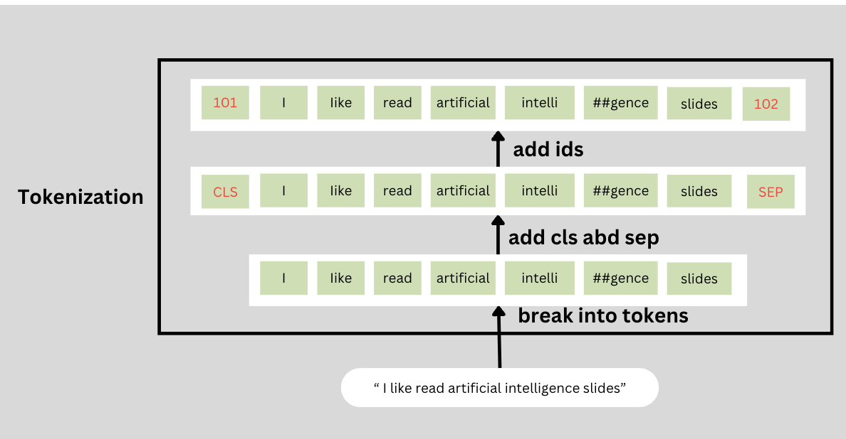

Image 6: Tokenizer visualization (Created by me with Canva)
- Padding: If the sense is too short and doesn’t match the max length, fill the sentence with [Pad]. Padding visualization is shown in image 7.

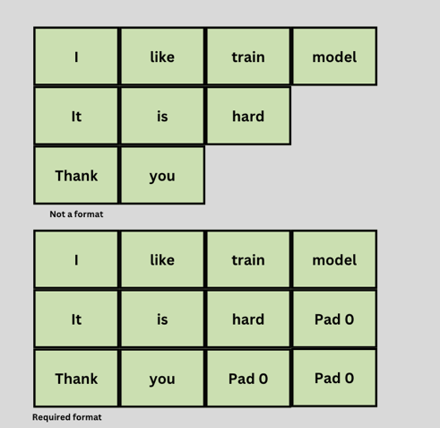

Image 7 padding visualization (Created by me with Canva)
- Truncation: If the input sentence is too long and exceeds the max length. Truncation will be applied, and cuts of the extra parts beyond the max length.
- Max_length: Max_length was set as a standard for padding and truncation to ensure each sentence has the same length.

The return value includes encodings and a torch. tensor(label.value)
  - Encodings: encoding is a technology used to convert human-readable texts into machine-learning models’ readable numerical representations. Encoding will be used after splitting the test into tokens, padding, and truncation. It includes “input_ids” and “attention_mask”.
    - “input_ids”: These IDs are also called token IDs, after splitting text into tokens, each token will be assigned a special ID.
    - “attention_mask”: Attention_mask aims to tell the model which tokens are real content and which tokens are [Pad], a padding signal only to extend the length. So it only contains two values [0, 1]. 0 represents [Pad] and 1 represents real tokens.
  - Torch.tensor(): texts were converted into tensors (multi-dimensional arrays), ensuring they can be analyzed by PyTorch. This process is done by using the torch.tensor().

  - Model Training

Technology: BERT model training.

BERT applies bidirectional training of the Transformer, a popular model for language modeling. Rather than single-directionally trained, it combined lefty-to-right and right-to-left, generating a bidirectional model training. It analyzes context based on its left and right texts, giving it a deeper sense of language context than the single-direction language model.

Transformer learning means using existing tasks to pre-training a neural network model, and for a new specific model, the developer needs to fine-tune the trained neural network model. The key technology used in Transformer learning models includes an encoder that reads the text input and a decoder that outputs prediction for specific tasks. BERT aims to generate a language model, so it only uses an encoder mechanism.

When defining a prediction during the model training, the directional approach faces limitations on context learning because it predicts the next word in sequence. To avoid such limitations, BERT uses two training strategies: Masked LM (MLM) and Next Sentence Prediction (NSP).
- Encoder: the input of the Transformer encoder is a sequence of tokens (generated in data processing). The output is a sequence of vectors, each vector relates to an input token with the same index (generated by encoding).
- Masked LM (MLM): before inputting word sequence into BERT, 15% of words will be replaced by [MASK] tokens. The model will try to use other unmasked words to predict the original words of [MASK] tokens. Image 8 shows the process of encoder and MLM.
  - Firstly, BERT will create a new classification layer beyond the encoder’s output.
  - Secondly, it will multiply the output vectors by the embedding matrix, to convert them into vocabulary dimension.
  - Finally, it will use SoftMax to calculate the probability of each word in the vocabulary.

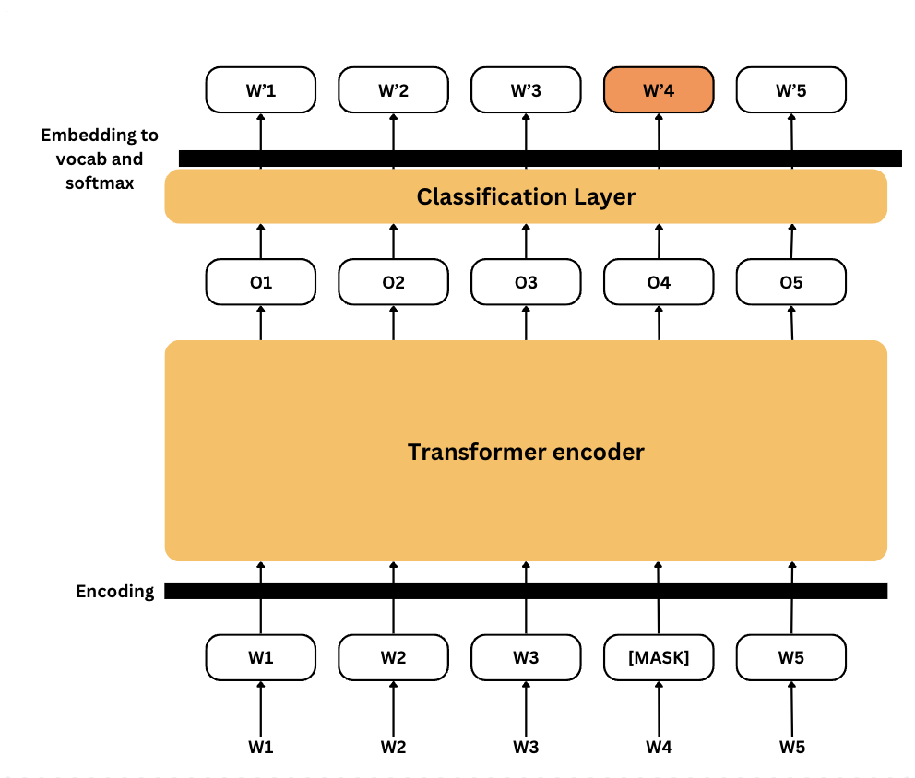

Image 8: Encoder and MLM (Created by me with Canva)
- Next Sentence Prediction (NSP): during BERT training, the model receives pairs of sentences as input and learns to predict if the second sentence inside the pairs is the subsequent sentence in the original document. In the training, 50% of sentence pairs are real pairs and the second sentence is the subsequent sentence in the original document. The rest 50% are fake pairs and the second sentence is a random sentence chosen from the corpus. The sentence pairs need to be processed to help the model make such a prediction and the image 9 visualizes the preprocessing:
  - Insert a [CLS] token at the beginning of the first sentence, and a [SEP] token at the end of each sentence.
  - Add sentence A or sentence B’s sentence embedding EA or EB to each token.
  - Add a positional embedding En (n is a constant number) in each token to show its position inside the sequence.

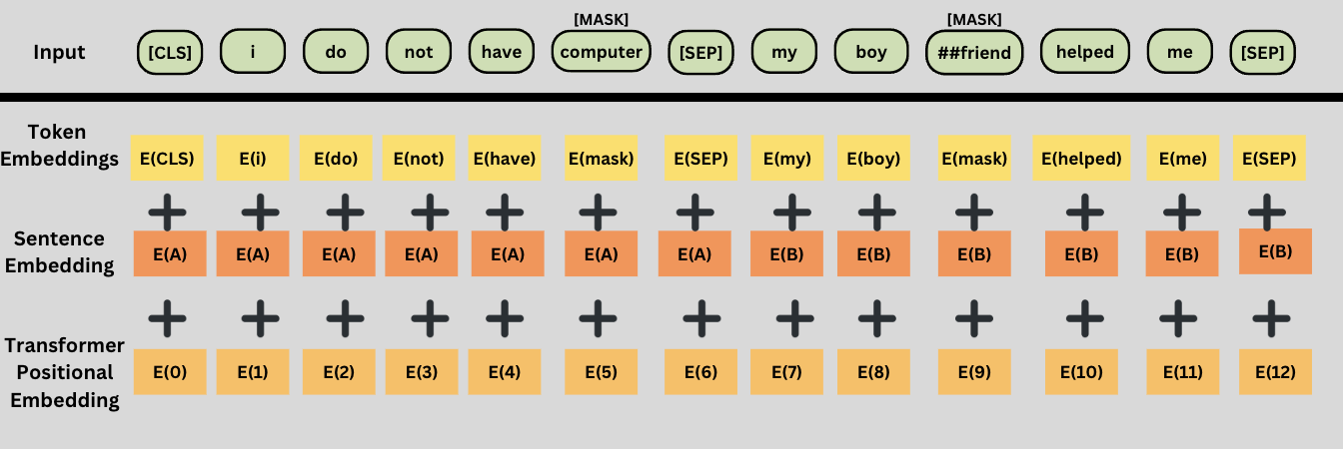

Image 9: Sentence preprocessing visualization (Created by me with Canva)

BERT modeling was chosen based on its high reliability and accuracy. This project trained 3 models with BERT technology by changing the key variables.
  - Model Validation

Technology: K-Fold Cross-Validation.

Explanation: K-Fold Cross-Validation is the most widely used cross-validation method for evaluating a model’s performance and generalizability. It divides the dataset into subsets, training, and testing models in different subsets. The following shows the detailed steps for K-Forld Cross-Validation and image 10 visualizes such a technology.
- Firstly, split the input dataset into K equal-size folds.
- Secondly, for each fold, train the model with K-1 folds and validate it with the rest of one fold. Repeat this process with K times, ensuring each fold can be used as a validation set once.
- Finally, calculate the performance metrics (accuracy, precision, recall) based on averaging the performance metrics value of all folds.

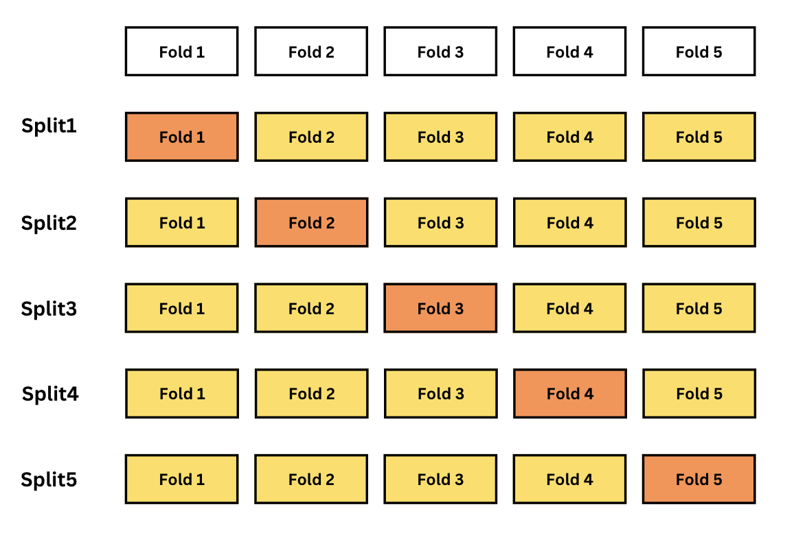

Image 10: K-Fold Cross-Validation with K = 5 (Created by me with Canva)

For example, with K=5, the dataset will be used 5 times (Split in image). For each split, one fold will used as a validation fold, and the rest 4 folds will be used as training folds. Change the validation fold and training folds five times.

In the project, K-fold training was combined with variable epoch x, which means that for each fold (split in the image), the same training and validation will be run in x times. For example, setting fold K=5 and epoch x equal to 5 means the 900 abstracts will be separated into five folds, and each fold will contain 180 abstracts, each fold will be used as a validation subset 5 times. Here is an example output:

Fold 1: epoch 1 complete;

Fold 1: epoch 2 complete;

…….

Fold 1: epoch 5 complete;

Fold 2: epoch 1 complete;

……

Fold 2: epoch 5 complete;

……

……

Fold 5: epoch 5 complete.

The main reason the K-Fold Cross-Validation was used in the project is to reduce overfitting. Overfitting happens when a model learns too much from training data and performs poorly on unseen data. K-FoldCross-Validation can average the performance by using multiple splits, ensuring the model trains on diverse subsets, and avoiding overlearning.
- Experiment
  - Experimental Setup
    - overall experiment: the CSV file “research_abstracts.csv” containing 900 abstracts for astronomy, psychology, and sociology was used as a dataset for BERT model training and validation. To generate a BERT model with high accuracy, variables like epoch size and number of folds in K-fold are changed during the experiment. The accuracy of the generated model is evaluated with performance metrics, including accuracy, precision, recall, and F1-score. The Python code outputs the performance metrics for each epoch, fold, and overall model to show the influence of these variables on model training. At last, the generated model was saved with “.pth” as an extension. Totally three models are generated by the same Python code (only with variable changing). The details of the variable change will be explained in the following part.

    - Parameter changing:

A total of three models were generated based on different epochs and k-fold, table 1 shows these three models.
 | Epoch | K-Fold
Model 1 | 5 | 3
Model 2 | 5 | 5
Model 3 | 10 | 5

Table 1: Three models with different epochs and K-Fold

Model 1: divide 300 abstracts (one field) into three folds, each fold containing 100 abstracts. Using one fold as a validation subset and the remaining two folds as a training subset to train the data 5 times (epoch size). Iterate such process 3 (K-value) times. For each iteration, change the validation subset.

Model 2: divide 300 abstracts (one field) into five folds, each fold containing 60 abstracts. Using one fold as a validation subset and the remaining four folds as a training subset to train the data 5 times (epoch size). Iterate such process 5 (K-value) times. For each iteration, change the validation subset.

Model 3: divide 300 abstracts (one field) into five folds, each fold containing 60 abstracts. Using one fold as a validation subset and the remaining four folds as a training subset to train the data 10 times (epoch size). Iterate such process 5 (K-value) times. For each iteration, change the validation subset.

Epoch changing: can improve the model learning by giving it more opportunity to learn from the dataset. A higher epoch can avoid some data missing and learning mistakes. However, it has a limitation that above such epoch value, the accuracy of the model will not be improved, which will be shown in the result part. Image 11 shows the original code for epoch changing.

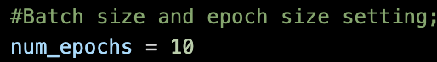

Image 11: Parameter epoch in the code

K-Fold changing: a higher K value can improve the model accuracy by smaller the dataset. A smaller dataset can make the learning more specific and crucial. Image 12 shows the original code that was used for epoch-changing.

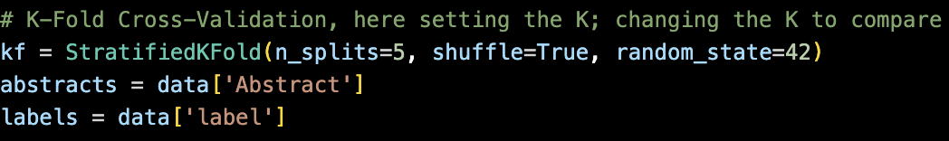

Image 12: Parameter K-fold in the code
  - Challenges and Adjustments
    - From Colab to Pycharm

At first, the Python code was running on the Colab, using an online environment, CPU, and GPU. However, for a fold with epoch 5, it took more than 2 hours to run the code. For this project, each model needs over 8 hours running. Moreover, the code stops twice because of the unstable connection with the Colab. Extreme long code running and unstable connection show Colab is not a good choice for running the code. After the second code running stopped, the main application was switched to using Pycharm on the computer. One computer with a great GPU and CPU was rented to run the code.

After switching to the computer, the Python code ran supper quickly, for a fold that contained 5 epochs, the computer only needed 1 to 2 minutes to complete it.

    - Fix Batch size

Batch size problems first occur when using Colab to run the code, when the Batch size was set to 32 and 16, the code running stopped in the middle and sucked, the Colab only can handle a code running with batches 8 and 4. After switching to the computer, the batch size was set to 16 to maintain the high model training accuracy and speed.
- Results
  - Performance Metrics and Confuse Matrix

4.1.1 Evaluation of each model

The following sections show the performance metrics for each fold in each model training and overall performance metrics and confusion matrix for each of the three models.

Overall confusion matrix = Fold 1 confusion matrix + Fold 2 confusion matrix +….+Fold K confusion matrix. Image 13 shows the explanation of the generated confusion matrix.

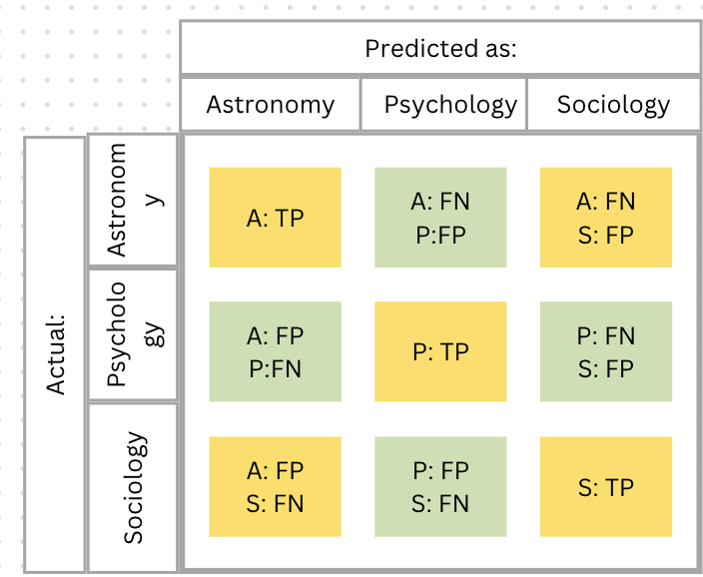

Image 13: 3 X 3 confusion matrix.

#T (True): when the predicted field and actual field are the same.

#F (False): when the predicted field is different from the actual field.

#P (Positive): predicted as this field.

#N (Negative): not predicted as this field.

#A, P, S: represented astronomy, psychology, and sociology.

Using row 1 as an example, the actual field of raw 1 is astronomy, if row 1 shows [296, 0, 4], that means in 300 abstracts of astronomy, 296 abstracts were correctly classified in astronomy, 0 abstracts were wrongly classified in psychology, and 4 abstracts were wrongly classified in sociology.

Overall performance metrics: here are formulas of performance metrics with the confusion matrix values.

Accuracy $=\frac{Total correct predictions}{Total predictions}$=$\frac{Diagonal sum of confusion matrix}{Matrix Sum}$

Precision = $\frac{True Positives}{True Positives+False Positives}$

Recall = $\frac{True Positives}{True Positives+False Negatives}$

F1-Score = 2*$\frac{Precision*Recall}{Precision+Recall}$
- Model 1: Epoch 5, Fold 3. The performance metrics are described in Table 2.
 | Accuracy | Precision | Recall | F1-Score
Fold 1: | 0.9667 | 0.9673 | 0.9667 | 0.9668
Fold 2: | 0.9800 | 0.9806 | 0.9800 | 0.9801
Fold 3: | 0.9933 | 0.9934 | 0.9933 | 0.9933
Overall: | 0.9800 | 0.9802 | 0.9800 | 0.9800

Table 2: Perform metrics for Model 1

The overall confusion matrix is described in chart 1.

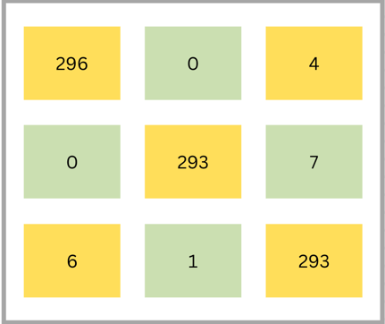

Chat 1: Overall confusion matrix for model 1
- Model 2: Epoch 5, Fold 5. The performance metrics are described in Table 3.
 | Accuracy | Precision | Recall | F1-Score
Fold 1: | 0.9611 | 0.9620 | 0.9611 | 0.9612
Fold 2: | 0.9833 | 0.9836 | 0.9833 | 0.9833
Fold 3: | 0.9778 | 0.9778 | 0.9778 | 0.9777
Fold 4: | 0.9889 | 0.9891 | 0.9889 | 0.9888
Fold 5: | 1.0000 | 1.0000 | 1.0000 | 1.0000
Overall: | 0.9822 | 0.9823 | 0.9822 | 0.9822

Table 3: Perform metrics for Model 2

The overall confusion matrix is described in chart 2.

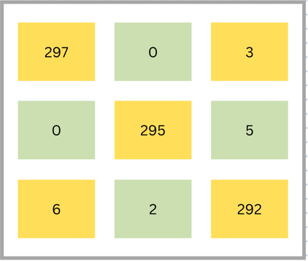

Chat 1: Overall confusion matrix for model 2
- Model 3: Epoch 10, Fold 5. The performance metrics are described in Table 4.
 | Accuracy | Precision | Recall | F1-Score
Fold 1: | 0.9611 | 0.9620 | 0.9611 | 0.9612
Fold 2: | 0.9833 | 0.9836 | 0.9833 | 0.9833
Fold 3: | 0.9778 | 0.9778 | 0.9778 | 0.9777
Fold 4: | 0.9889 | 0.9891 | 0.9889 | 0.9888
Fold 5: | 1.0000 | 1.0000 | 1.0000 | 1.0000
Overall: | 0.9822 | 0.9823 | 0.9822 | 0.9822

Table 4: Perform metrics for Model 3

The overall confusion matrix is described in chart 3.



Chat 3: Overall confusion matrix for model 3

  - Epoch:

Epoch limitation: epoch limitation refers to an epoch value that exceeds this epoch, the model accuracy will become stable and no longer be influenced by testing the same training dataset again and again. To find the limitation, the code generated output with model accuracy calculation for each epoch. Image 14 shows the output of epoch accuracy.

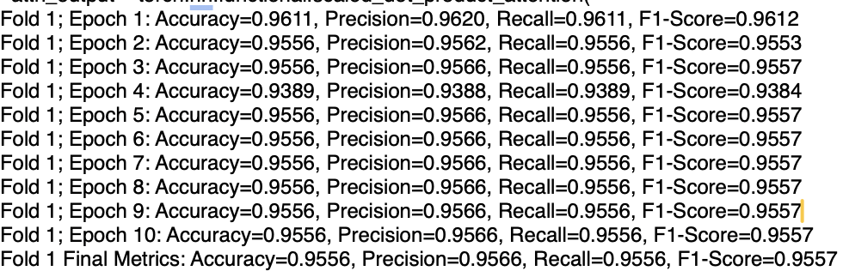

Image 14: Epoch accuracy

The accuracy score maintained the same after epoch 5, which shows that 5 is the highest value of epoch that can improve BERT model training accuracy. The same result also can be discovered from the overall performance value of models 2 and 3. Models 2 and 3 have the same K-fold, model 2 has an epoch value of 5, and model 3 has an epoch value of 10. However, their overall performance metrics and confusion matrix are the same. This shows that since epoch 5, the model will be no longer influenced by epoch.

  - Impact of Adjustments

Table 5 compares all adjustments during the experiment.
Parameter | Values | Best Value | Prove
Epoches | 5, 10 | 5 | Model accuracy in above epoch 5 mentained same
K-folds | 3, 5 | 5 | Model 2 have better performance than model 1

Table 5: Parameter comparison

Model 2 and Model 3 have better preferences rather than model 1. However, since Model 3 has a higher epoch value that exceeds epoch limitation, its training and validation waste a lot of time, Model 2 was decided as the best model during the whole experiment.

- Conclusion

During the whole project, there are plenty of technologies were used, and these technologies were combined, tested, and evaluated in several different ways. Combined Web Scraping and Xiv web API facilitate the data acquisition process and avoid rate limitation, scraping reject, IP address prohibited, and website format distinct problems. BERT tokenizer is a mature and reliable way to preprocess text data for BERT models. Tokenizer splits human-readable texts into tokens and converts them into model-readable numerical representations by padding, truncation, and encoding. BERT model and K-Fold Cross-Validation are the two main technologies used for model training and validation. As a pre-trained model, BERT can handle the task only with some tiny modifications, which shows its high reliability. BERT used two strategies, including Masked LM and Next Sentence Prediction, to ensure its Bidirectional learning and prediction. K-Fold Cross-validation provides an important training and validating method for BERT models. It split the dataset into different subsets (folds) and iteration the training and validation by updating the new fold as a validation dataset. With these technologies, the whole project becomes highly reliable.

To generate a high-accuracy model, this project adjusted different parameters, including epoch and K-folds. There were three models were trained and validated during the experiment. By comparing their performance metrics and confusion matrix, model 2, with five epochs and 5-folds, was defined as the best model for this project. Epoch values have limitations, which means that higher epochs cannot always generate higher models.

However, there are still some considerations that need to be focused on in the future. Based on the time limitation and technology limitations, batch size, one important parameter hasn’t been tested. Batch size is also an important value that highly influences the BERT model’s accuracy, in future projects, this parameter needs to be considered and tested.

- References
Bharathi, B. (2024, December 18). Latest guide on confusion matrix for multi-class classification. Analytics Vidhya. https://www.analyticsvidhya.com/blog/2021/06/confusion-matrix-for-multi-class-classification/
Dhar, A., Mukherjee, H., Dash, N. S., & Roy, K. (2020). Text categorization: Past and present. Artificial Intelligence Review, 54(4), 3007–3054. https://doi.org/10.1007/s10462-020-09919-1
Horev, R. (2018, November 17). Bert explained: State-of-the-art language model for NLP. Medium. https://towardsdatascience.com/bert-explained-state-of-the-art-language-model-for-nlp-f8b21a9b6270
Jiang, X. (2024). Development of text classification methods based on Deep Learning. Proceedings of the 1st International Conference on Data Science and Engineering, 518–523. https://doi.org/10.5220/0012829500004547
Minaee, S., Kalchbrenner, N., Cambria, E., Nikzad, N., Chenaghlu, M., & Gao, J. (2021). Deep learning-based text classification. ACM Computing Surveys, 54(3), 1–40. https://doi.org/10.1145/3439726
Now), H. H. (Here &. (2024, December 17). Understanding k-fold cross-validation: A comprehensive guide. Medium. https://blog.gopenai.com/166-80adfd6f2066

